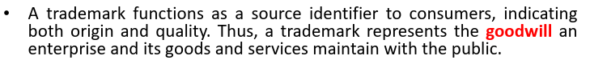



Trademarks are very attractive to SMEs (small middle enterprises)

